Recovering Your Joy
Rev. Douglas R. Vavrosky
Rom 14:17 For the kingdom of God is not a matter of eating and drinking, but of righteousness, peace and joy in the Holy Spirit,
- Joy in the Kingdom of God
Rom 14:17 For the kingdom of God is not a matter of eating and drinking, but of righteousness, peace and joy in the Holy Spirit,
- Admit that you have lost it
Ps 51:12 Restore to me the joy of your salvation and grant me a willing spirit, to sustain me.
- Analyze the Cause
Lam 3： 40 Let us examine our ways and test them, and let us return to the LORD.
Joy doesn’t just drop away, if you lose your joy it is because it has been stolen.
Kill joys
- Unbalanced schedule
- Unused talent
- Unconfessed sin
- Unresolved conflict
- Undernourished spirit

- Correct what’s wrong
John 15:10-11 If you obey my commands, you will remain in my love, just as I have obeyed my Father’s commands and remain in his love. 11 I have told you this so that my joy may be in you and that your joy may be complete.
James 4:17 Anyone, then, who knows the good he ought to do and doesn’t do it, sins.
II. By doing what God tells one to do, A person can choose how much joy he or she wants
A. Daniel overcame the lions
B. Paul and Silas overcame Philippi
C. Joseph overcame Egypt
III. How to Recover Your Joy
A. Think about the good in my life
Ps 126:3 The Lord has done great things for us, and we are filled with joy.
The attitude of gratitude is the healthiest human emotion.
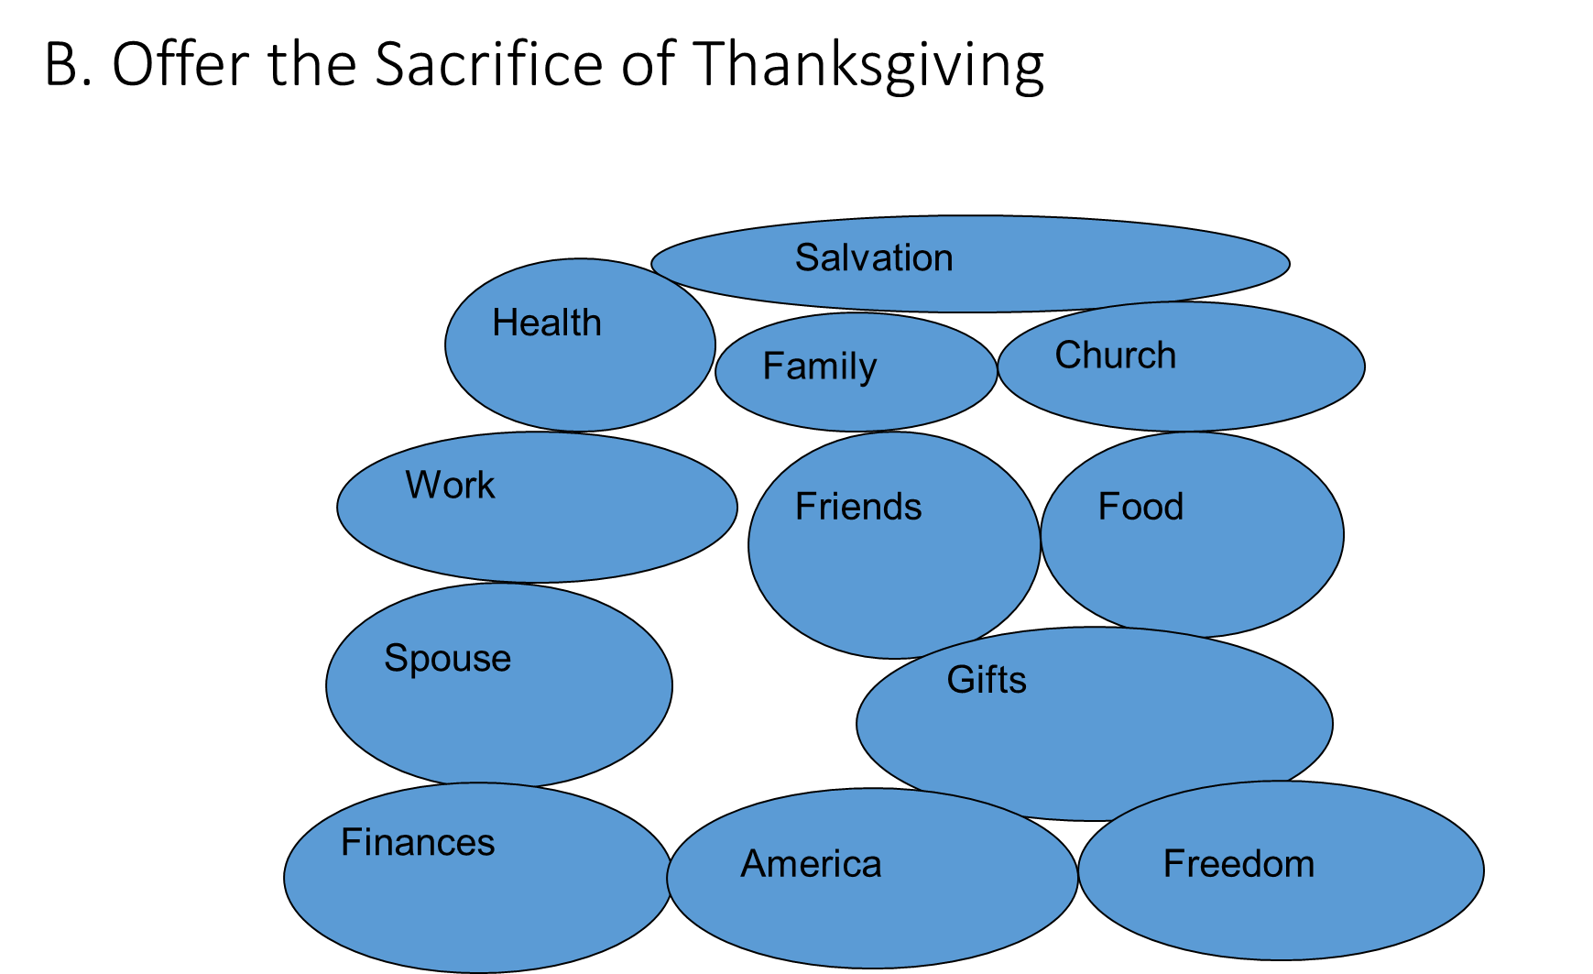
C. Spend Time with God everyday
Jer 15:16 When your words came, I ate them; they were my joy and my heart’s delight, for I bear your name, O Lord God Almighty.
John 16:24 Until now you have not asked for anything in my name. Ask and you will receive, and your joy will be complete.
D. Find a way to give back
Eph 2:10 For we are God's workmanship, created in Christ Jesus to do good works, which God prepared in advance for us to do.
Joy comes from serving
Acts 20:35 In everything I did, I showed you that by this kind of hard work we must help the weak, remembering the words the Lord Jesus himself said: ‘It is more blessed to give than to receive.’“
E. Tell Someone about Jesus
Luke 15:7 I tell you that in the same way there will be more rejoicing in heaven over one sinner who repents than over ninety-nine righteous persons who do not need to repent.
When you help someone come to Christ there is a party in your heart.
JOY COMES FROM GOD
Conclusion：
Joh 7:37 On the last day of the feast, the great day, Jesus stood up and cried out, "If anyone thirsts, let him come to me and drink.38 Whoever believes in me, as the Scripture has said, 'Out of his heart will flow rivers of living water.'"39 Now this he said about the Spirit, whom those who believed in him were to receive, for as yet the Spirit had not been given, because Jesus was not yet glorified.

